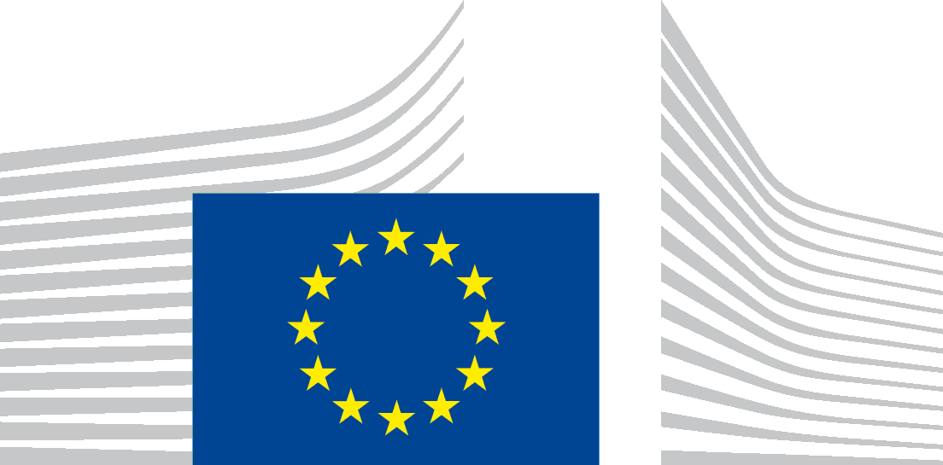 | EUROPEAN COMMISSION  DIRECTORATE-GENERAL FOR RESEARCH & INNOVATION  Deputy Director-General 1 - SCIENCE & POLICY TRANSITIONS  DDG1.03 - "Chief Scientific Advisers – SAM, EGE"

Standing Identification Committee for the ERC Scientific Council
Statement on methodology

1. Introduction
ERC Scientific Council members are appointed by the European Commission on the basis of a search process carried out by an independent Identification Committee for the selection of future members of the ERC Scientific Council (referred to hereafter as ‘the Identification Committee’). The search process includes a consultation of the scientific community, according to the provisions of the Horizon Specific Programmes. The Identification Committee carries out its work independently and transparently.
The current identification process relates to the appointment of Scientific Council members who will come into office on 1 January 2021, at the start of Horizon Europe. The consultation exercise will contribute to this and possibly future identification processes. The Committee hereby publishes the methodology that will be adopted for the consultation, which follows closely the approach used at previous occasions.

2. Consultation of the research community
The Committee works on the basis of a pool of possible candidates for Scientific Council membership covering all fields of science and scholarship. It is envisaged that the pool will be regularly updated in order to provide candidates for future renewal of the Scientific Council, including potential retirements or resignations.
The Committee considers it should actively consult the main organisations representative of the various segments of the research community at European level (see below). The consultation will be done by means of a letter from the Chairman of the Committee to the President of each organisation.
The consultation will not necessarily be the exclusive source of candidates. Candidates put forward during previous consultation exercises will also be considered and it will be open to other representative organisations and the members of the Committee themselves, to suggest other possible candidates. However, self-nominations will not be considered. All candidates, regardless of source of nomination, would be considered by the Committee using the same process as described in Section 4.

3. Factors and criteria to be taken into account
The composition of the Scientific Council must demonstrate that the Council can exercise authoritative and absolutely independent scientific leadership, combining wisdom and experience with vision and imagination.
The credibility of the Scientific Council is built on the balance of qualities amongst the men and women who make it up. An appropriate gender balance is a must.
The Members of the Scientific Council should collectively reflect the full breadth of the research community across Europe. They must individually have an undisputed reputation as research leaders and for their independence and commitment to research. Generally they must be current or recent research practitioners that exercised scientific leadership at European or world level. Proper consideration should also be given to younger, next-generation leaders.
Members must reflect the broad disciplinary scope of research, embracing the exact sciences and engineering, as well as the social sciences and humanities. However, they should not be considered as representatives of a discipline or of a particular line of research and should not perceive themselves as such; they should have a broad vision which reflects an understanding of important developments in research, including inter and multidisciplinary research, and the needs for research at European level.
For example, it is crucial that relevant expertise is represented when the Council is considering the increasing role played by computational techniques (notably machine learning and database management) in both the sciences and the humanities. This includes the integration of such techniques into relevant scientific domains, implications for methodological integrity and considerations of further ethical, economic and political impact.
Beyond their proven reputation as scientists and researchers, the membership should collectively bring a broader range of experience, acquired not only across Europe but also in other research-intensive parts of the world. This could include experience in areas such as support and promotion of basic research or organisation and management of research and knowledge transfer in universities, academies, business and industry, and an understanding of national and international research activities, relevant research funding schemes and the wider political context in which the European Research Council is situated.
The membership should reflect the various components of the research community and the range of scientific institutions which carry out research; it should include those with experience in universities, research institutes, academies, funding bodies or research in business and industry and those who have experience in more than one country. Some members may also be drawn from the research community outside Europe.

4. Methodology
To draw up the list of candidates, the organisations consulted (and others who wish to nominate individuals) will be asked to provide suggestions of persons who in their estimation:
- have the highest eminence as research leaders and the qualifications and experience reflecting the criteria set out above;
- are available and willing to work as a member of the ERC Scientific Council independently of any other interest, and
- would be expected to have the trust and confidence of the scientific community.

The committee will regard the names and personal details of candidates as confidential. The committee will only consider candidacies that will be accompanied by a short statement by the nominating organisation regarding the qualifications and broader profile of each candidate, adequate for it to make an informed judgement. This would be expected to include:
- A synopsis of the candidate’s background and curriculum vitae;
- Relevant professional experience (e.g. universities, scientific institutions, business, government, etc., indicating also any administrative or science policy experience);
- Research interests and experience (indicating the major research projects in which the candidate has been involved);
- Major publications and other significant works and prizes;
- Broader aspects of the candidate as appropriate (e.g. country of residence, experience abroad, nationality).

It is recommended to use the attached template ‘Statement of the qualifications and broader profile of candidate’ in order to provide information about the qualifications of the proposed candidates.
The Committee recognises that the availability of persons to participate in the Scientific Council will be affected by the precise duties of the latter. It should be noted that the Scientific Council currently meets typically 5 times per year for 2 day meetings which are held normally in Brussels or other European capital cities and are conducted in the English language.
While nominations of individual candidates would not be any guarantee of selection, the Committee would expect that the nominating bodies would establish the willingness of candidates to serve before their names were forwarded to it.

5. Main representative organisations to be consulted
- Academia Europaea
- ALLEA (European Federation of Academies of Sciences and Humanities)
- BUSINESSEUROPE
- CESAER (Conference of European Schools for Advanced Engineering Education and Research)
- EARTO (European Association of Research and Technology Organisations)
- EASAC (European Academies Science Advisory Council)
- EIRMA (European Industrial Research Management Association)
- EUA (European University Association)
- Euro-CASE (European Council of Academies of Applied Sciences, Technologies and Engineering)
- LERU (League of European Research Universities)
- The Guild of European Research-Intensive Universities
- Science Europe (Association of European Research Funding Organisation and Research Performing Organisations)

As indicated earlier, the Committee also invites other interested representative organisations of the scientific community to put forward high level nominations during the same period of consultation.

6. Provisional timetable for the further work of the Committee
The provisional schedule for the next stages of the Committee’s work is as follows:
- Mid-July 2020 – consultation letters sent to representative organisations
- 30 September 2020 – receipt of proposed candidates and relevant information
- October 2020 - evaluation of candidates
- End of October 2020 – confidential proposal to the European Commission
- November 2020 – report of the Identification Committee

7. Electronic address for the consultation
Organisations should send the nominations to the following electronic address by 30 September 2020: RTD-ERC-ID@ec.europa.eu

Members of the Identification Committee:
- Carl-Henrik HELDIN (chair) - Uppsala University, Chairman of the Board of the Nobel Foundation, Sweden
- Barbara FLUECKIGER – Zürich University, Switzerland
- Kirsten GRAM-HANSEN – Aalborg University, Denmark
- Michal KAROŃSKI – Adam Mickiewicz University, Poland
- Carlos MARTINEZ ALONSO – Spanish National Research Council, Spain
- Mira MEZINI – Technical University of Darmstadt, Germany/Albania

The Identification Committee was renewed in May 2020, following a consultation of the scientific community. A News Alert can be found here.
Article 7.1 of the Council Decision (2013/743/EU) of 3 December 2013, establishing the specific programme implementing Horizon 2020 - the Framework programme for Research and Innovation (2014-2020) and article 7.1 of the proposal for a Council Decision on establishing the specific programme implementing Horizon Europe - the Framework Programme for Research and Innovation (2021-2027).

